ECA0303-SIGNALS AND SYSTEM
NAME : BHARATH A
REG NO : 192512384
Experiment 1.2
Generation of Discrete Time Signals
Program:
% Generation of Discrete Time Signal
clc;
clear;
close all;
% Discrete-time index
n = -10:10;
% Discrete-time sinusoidal signal
x = sin(0.2*pi*n);
% Plotting
figure;
stem(n, x, 'filled');
grid on;
title('Discrete Time Sinusoidal Signal');
xlabel('Sample Index (n)');
ylabel('Amplitude');

Output Waveform:
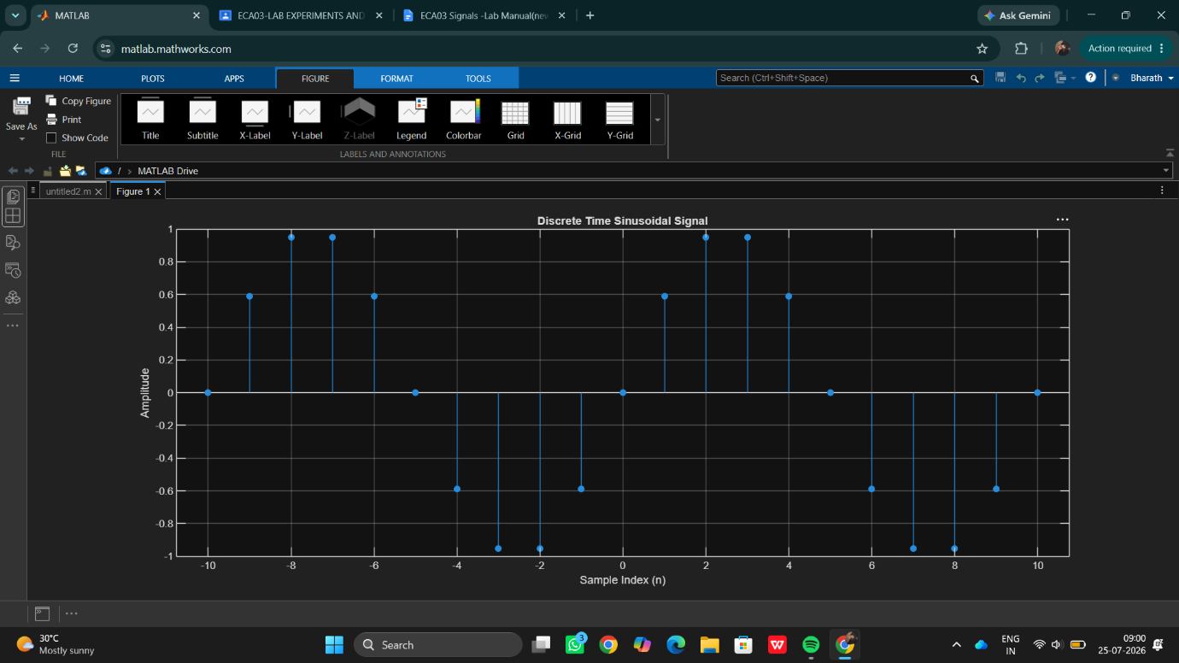

Result:
This test case validates that the signal generator can accurately produce a discrete-time unit impulse signal at a specified index, which is essential for analyzing the response of discrete time systems.

